ITP 125 – Homework 04

Deadline

1 minute before the next class.

Objective

More Python. Boo!

Procedure

1. Goto <http://www.codecademy.com/tracks/python>.

Remember to carefully read the lesson on the left.   
  
**Important:** think about what you are doing, and don’t just follow blindly.

1. Do lessons the following lessons:

*Advance Topics in Python*

*Advance Topics in Python*

***Introduction to Bitwise Operators***

*Introduction to Classes*

*Introduction to Classes*

***Classes***

*File Input and Output*

***File Input/Output***

The lessons in bold will be the code that you will be submitting for a grade.

When you finish you should see something like this on bottom of the screen:



1. Before you can submit the lab, you will need to copy to code into a text editor like Notepad (Windows) or TextEdit (OSX). This next screenshot is the code that you need to copy from

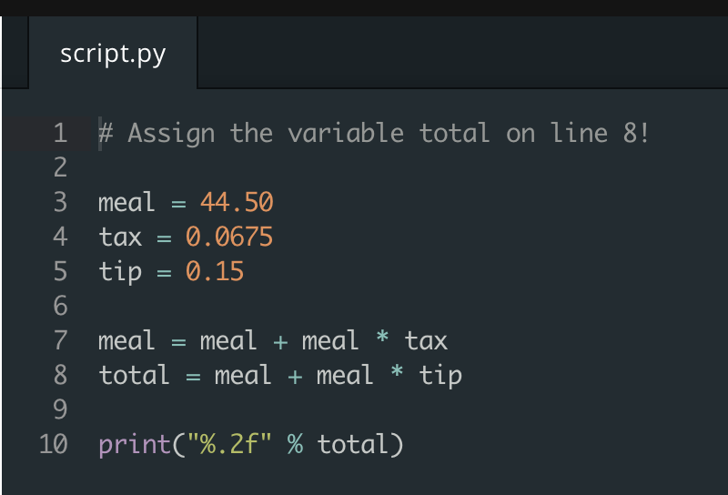  
  
**The only code that you will need to submit is from lessons “Introduction to Bitwise Operators”, “Classes”, and “File Input/Output”**

1. After you have copied the code, paste it into a text editor so it looks something like this:

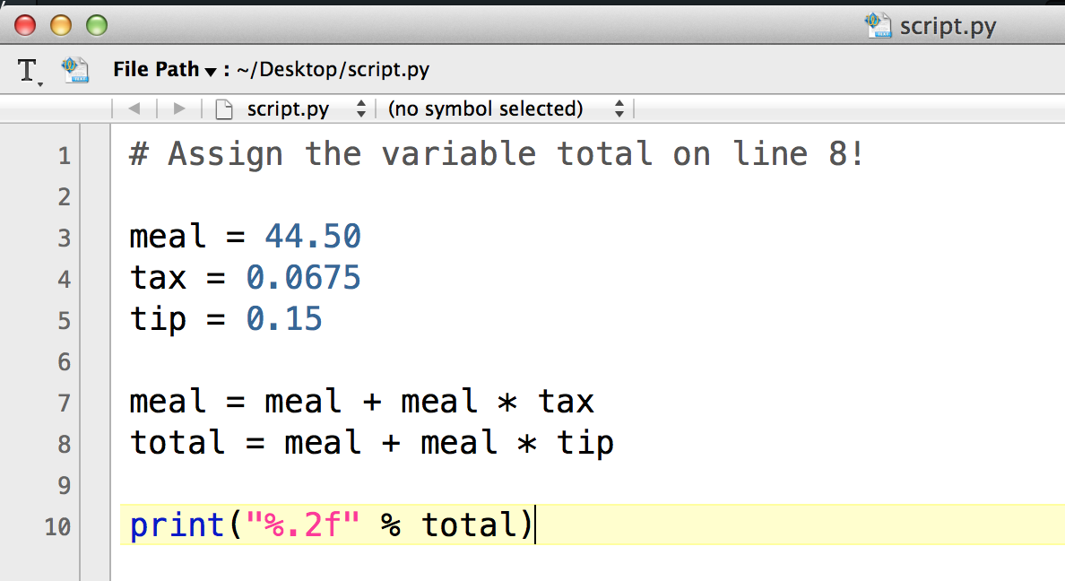

Save the file and name it as the following:

Introduction to Bitwise Operators 🡪 hw04a.py

Classes🡪 hw04b.py

File Input/Output🡪 how04c.py

Submission

After you are done with answering the questions, name the file **hw04a.py, hw04b.py, and hw04c.py** then encrypt the file using **7zip or Keka**, and. Upload the file to your **itp125 folder** on the web hosting.

Set the password to be **pythonislovepythonislife**

Make sure you can see the file by publicly accessing the URL using any web browser of your choosing.

Refer to lab 1 if you are having any issues.